Progress Reports

Kurt Robinson

# Progress Report for 19th March

## Week One

The project assigned requires us to develop a piece of software that serves as a dashboard capable of visualising data in a meaningful way and allowing the user to manipulate the given data. This progress report was written two days after our first meeting and its purpose is to provide an insight into how development of this project is coming along.

As we have only had one day since our first meeting we were still able to go over our project specification and identify who the stakeholders of the software would be, we also discussed some requirements that the software would have to fulfil as well as some resources that we would require in order to properly develop this software.

During our meeting we dedicated some time into opening the archive files given to us and conducting research to get an early idea of what type of data we would have to work with throughout this project.

## Decision Table

|  |  |  |
| --- | --- | --- |
| Description | Decision | Priority |
|  |  |  |
| Design Methodology | We have chosen to follow the agile development methodology.  It is preferable to each group member as we wish to complete tasks in bursts using an incremental and iterative method. | Neutral |
|  |  |  |
| Programming Language | Our choices were between Cocoa, C++, Java or Visual Basic.  Our final decision will be based on ease of use and its ability to support a GUI, for now it is undecided as it is not a high priority at this point in time. | Low |

## Issues

A large issue we had was not being able to have a group formed until the third week of semester, leaving us only four weeks to complete all our tasks until the first deliverable rather than 6. This means that we will need to organise frequent and extended group meetings in order to produce a quality report in time.

## Action Items

### Completed

*No action items had been set the previous week*

### Assigned

Action items that were assigned at the end of the meeting that we planned to have completed by the next week included a design plan, business case, an initial SRS, measuring effectiveness, milestones, risk analysis and a git repository created for the project.

## Current Status

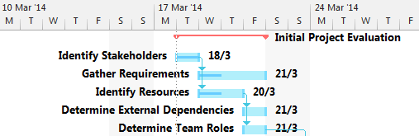

The Gantt chart does not show us much regarding how much has been completed since we have only had one day to put work into the task.

# Progress for 26th March

## Week Two

This week we had all members present during the Tuesday tutorial so we were able to set a weekly date that we can all get together and simultaneously work on this project. The date chosen that suited us best was on Wednesdays at 5:30pm.

We were able to meet with the client and we gathered some requirements including security details, database updating, and user details. These are taken into more detail within the SRS document.

Peter has chosen to handle development on the front end of the software. Meaning he will handle the website and data visualisation while the others focus on the technical back end tasks.

Our team roles are as follows:

* James: Project Manager/Software Architect
* Kurt: Tool Specialist/Software Engineer
* Josh: Database Administrator
* Peter: UI Engineer/System Analyst
* Jamie: Software Engineer/Analyst

## Decision Table

|  |  |  |
| --- | --- | --- |
| Description | Decision | Priority |
|  |  |  |
| RDBMS* | We have chosen to use MySQL as our RDBMS due to its capabilities of supporting concurrent updating across multiple clients since our software will need to support many users at once. | Neutral |
|  |  |  |
| Team Roles | We all discussed preferable parts of the project that we would like to be a part of and were able to determine team roles from this. From doing this we were able to assign tasks to people with the role that would best suit them. Those roles are shown in this report. | High |
|  |  |  |
| Programming Language | We revisited this decision as we have looked into developing the software to be based inside a browser. This gave us two options of languages being PHP, JavaScript and Ruby. JavaScript has a tool named D3js tool that can be used to show graphs and visualise data aesthetically. However most of us decided that Ruby would be the best language for us to develop in as it also has many tools available and it is a simple language for us to learn. | Neutral |

*RDBMS: Relational Database Management System

## Issues

We had a small issue with communication where two members of our group had left early before our meeting with the client. However we were successfully able to complete our meeting with only three of us and gather more essential requirements.

## Action Items

### Completed

Through further discussion regarding development of the project we were able to come up with a design plan. A risk management report was also completed during the week and the milestones were decided on through creation of the Gantt chart. A git repository was also created with each team member added as collaborators.

### Assigned

Jamie and Kurt were assigned the feasibility study, Peter and Kurt were assigned the SRS, James and Josh were assigned the detailed plan. Everybody was advised to look into the Ruby language in their own time to become more familiar with what we will be coding with.

## Current Status

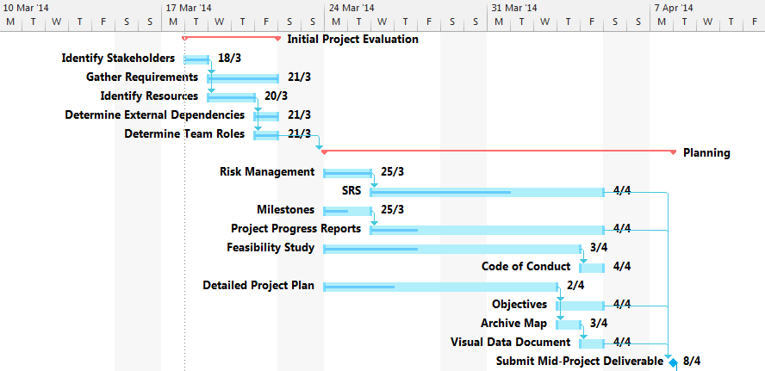

Once we were given team roles we were than able to work on our given tasks. We are now currently working on the SRS, Progress reports (this document), feasibility study and a project plan. The milestones document still requires completion.

# Progress for 2nd April

## Week Three

This week we spent time looking through the Python SVN, bugs website and archive files for bug reports, test cases, execution traces/logs, emails, discussions and emails. We were only able to find the bug reports and emails for now. We are searching for this data so that when we get to our import data stage we would immediately know where the data would come from, thus saving time for ourselves in the future. Peter and Josh also conducted a meeting with our client and received more requirements for the SRS.

The Wednesday meeting consisted of checking up with each other’s progress and helping each other out so we could gain a mutual understanding of different parts of the project.

## Decision Table

|  |  |  |
| --- | --- | --- |
| Description | Decision | Priority |
|  |  |  |
| How to import data | We decided to use Ruby’s integrated unarchiver to access the data supplied to us in the Python archive files. Importing data is an integral part of our project which was why it was classed as a high priority task. | High |
|  |  |  |
|  |  |  |

## Issues

We had an issue with locating the data in SVN and the Python Archives. As we still had current tasks to complete before the deliverable we decided to put this issue on hold for a week while we focused on our report.

## Action Items

### Completed

Action items from last week required more than a week to complete, hence why no items have been completed. Members also studied Ruby during the week.

### Assigned

A code of conduct is to be completed by Jamie, Objectives were assigned to James, completion of an archive map was assigned to Josh, Peter and Josh were also assigned to have a visual data document completed.

## Current Status

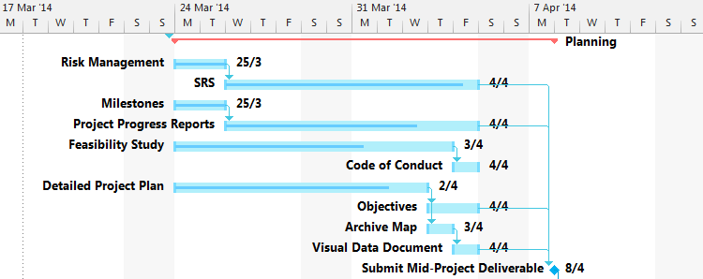

We have one week until our deliverable is due and each team member is still working on the same task as the previous week. The milestones document has also been completed.

# Progress for 7th April

## Week Four

This is the last week before our deliverable is due, therefore all tasks must be completed before the 8th of April (tomorrow).

All sections of the mid-project deliverable have been complete and we just have to format the document and prepare it for submission.

We must now progress to the iterative execution stage where Peter will

## Decision Table

|  |  |  |
| --- | --- | --- |
| Description | Decision | Priority |
|  |  |  |
| Design Methodology | We originally decided on agile development however we have specifically chosen feature-driven development. We feel that this would suit our project as we have design our development phases into iterations. (See Milestones Documet) | Low |
|  |  |  |

## Issues

Because of the first couple of weeks being behind on meetings and progress, we decided that we would host a secondary meeting on the Friday to ensure that all deliverables would be completed.

## Action Items

### Completed

All action items from last week have been completed in time for the deliverable.

### Assigned

Josh has been assigned to set up our MySQL database, James has been assigned to set up our code development environment, Jamie has been assigned to locate the required data from SVN and the Python archives while Peter has been assigned to set up tools required to host a website and begin development on that.

## Current Status

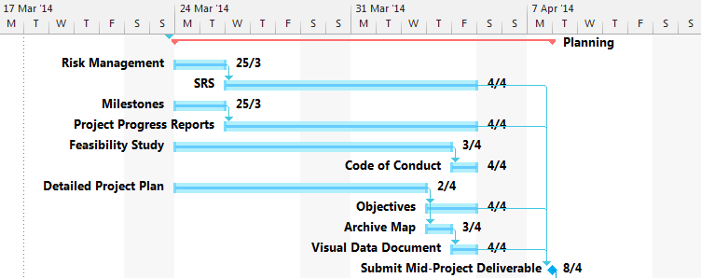

All tasks within planning phase of the project is complete and we are prepared to submit our report for the next milestone on the 8th of April. We are now ready to prepare for our execution stage and setting up the development environment.